Théâtre du Radeau François Tanguy

Soubresaut
Jolt
Premiere November 2nd 2016
Théâtre National de Bretagne à Rennes
Festival Mettre en scène

Coproductions
Théâtre du Radeau, Le Mans
Théâtre National de Bretagne - Centre Européen Théâtral et Chorégraphique
Festival d’Automne 2017, Paris
Théâtre National de Strasbourg
Centre Dramatique National de Besançon - Franche-Comté
Théâtre Garonne, Toulouse

Corealisation
Nanterre-Amandiers, centre dramatique national, Festival d’Automne à Paris

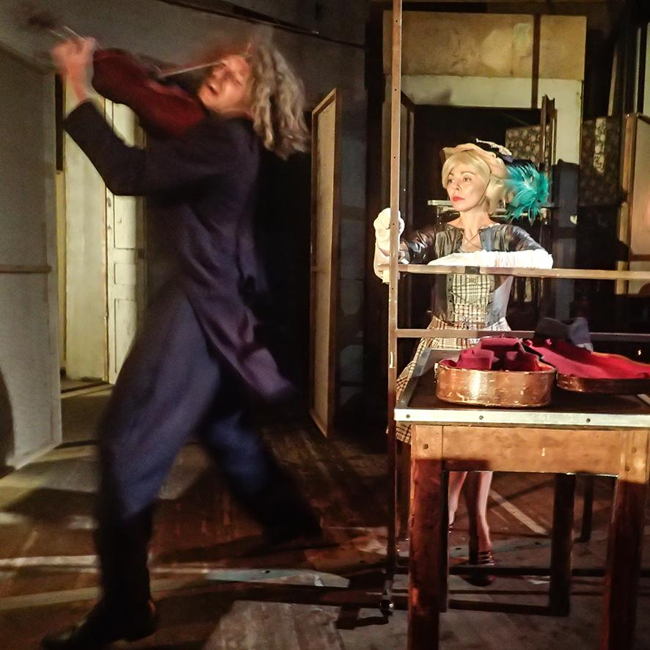
©Jean-Pierre Dupuy

On a stage bodies appear, disappear, say words that have been uttered hundreds of years before. What kind of memory are we talking about here, and why, and how does it still matter to us ?
François Tanguy

Théâtre du Radeau Soubresaut on tour
2017 : WHEN TO SEE SOUBRESAUT ?
Soubresaut will be in March 2017 at the Centre Dramatique National de Besançon-Franche-Comté
4 times between the 14th and the 17th march
More information on www.cdn-besancon.fr

Tuesday 14 march 8 pm
Wednesday 15 march 8 pm
Thursday 16 march 7 pm
Friday 17 march, 8 pm

The show will also be presented during Festival d'Automne 2017 at the Centre Dramatique National de Nanterre –Amandiers
15 times between the 22nd September and the 8th October 2017

SOUBRESAUT is available on tour
between November and December 2017 and between February and Augustus 2017

BASIC TECHNICAL REQUIREMENTS
The show requires a black-box setting with a playing area of 14m (wide) by 13,50m (deep). The minimum height under the technical grid is 6m.
There are 13 people on tour
.
A more detailed technical rider is available upon request. See contacts on the next page. Please not that the show is evolving in rehearsals on a daily basis. (See contacts on the next page)

Théâtre du Radeau François Tanguy
What is there, vacant within the space, could easily not be there.
- be clearer!
- yes.
- that, you see, is a traverse, and there, a pulley, maybe.
- and then?
- nothing ... you walk that plank, over the ravine
- not safe that plank
- not safe those banks ... so what? A question leads to another
- and the pulley?
- you've already passed it, it's no use.
François Tanguy

Director, scenography
François Tanguy

Sound
Éric Goudard - François Tanguy

Light
François Fauvel - Julienne Havlicek Rochereau - François Tanguy

Cast
Didier Bardoux
Frode Bjørnstad
Anne Baudoux
Jean-Pierre Dupuy
Muriel Hélary
Ida Hertu
Vincent Joly
Karine Pierre

Technical director
François Fauvel

Lighting technicians
François Fauvel
Julienne Havlicek Rochereau

Sound technician
Éric Goudard - Mikaël Kandelman

Set building team
Pascal Bence - Frode Bjørnstad - François Fauvel
Éric Goudard Julienne Havlicek Rochereau
Vincent Joly - Jimmy Péchard - François Tanguy

Admin & logistics
Nathalie Bernard - Leila Djedid - Annick Lefranc
Martine Minette – Nathalie Quentin

Théâtre du Radeau Soubresaut
Soubresaut
is the Théâtre du Radeau's twentieth creation.
« In this chaos of possible lines, we await the appearance of a trace that could be a decision of commitment, involving vision and a potential multiplicity, instantaneous, illusory.... Once this happens, the structure will move only in the imagination. »

« Hans Holbein's painting « The Ambassadors ». The models have long since gone the way of all flesh, and the effect, just as with the diplomatic effort they represent...offers the viewer only the intriguing sumptuary scutiny of pictorial construction.
The Pergamon friezes: (...)The carved marble frieze depicts the battle of the titans and the gods. »

« To escape the fray without leaving it, at the risk of revealing, with each step, the subterfuges. »
« Needless to say, facing the latticework overgrown with reasons, one creates. »

« Theatre? It is to resist, not to take back, not to reconquer because we have lost. To resist, that means to remember: memory is before, not behind, us. »

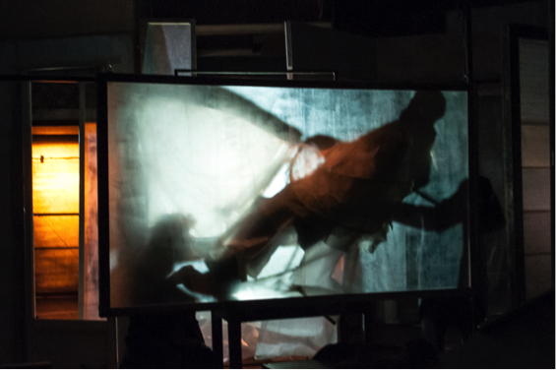
©KarinePierre

Théâtre du Radeau like nothing else
Le Radeau offers atypical scenic arrangements made of bodies, texts, voices, lights, sounds music and places that cross, mingle, answer to each other... The places could be scenery in-the-making or a painter's workshop where tables, chairs, frames of all sizes wold be scattered... Their theatre appears like a precarious and moveable installation, made of ordinary found objects holding together by the kinetic energy of its actors. Words, from multiple sources are sometimes hardly uttered, sometimes in strange languages, sometimes declamatory like in ancient theatres... The music, omnipresent, echoes classical and contemporary pieces, looped, superimposed, mixed with soundscapes... In turn, the whole is in tune, connected, undone, opposed. This place will call for that gesture, this movement will match that light; a dress colludes with a piece of music, a glance, a word or a face will connect with a table, an abandoned frame, temporary vanishing point.
Eric Vautrin in Théâtre Public "Variations Radeau" n°214, October 2014

If François Tanguy's theatre can be qualified as political, this is not because of its themes that would follow History-in-the-making, not because of his personal convictions nor because of how and where the work is created; it is by the constant and ceaseless transformations he pushes into the very matter of images, and by the way it invites audiences to re-activate, as vividly as possible, the way they perceive things."
Emmanuel Wallon - in "Croisements d'écritures" - Mimétis, Milano 2015

How it is formed? For, strictly speaking, these are not dreams, there is no fantasy: everything said here has already occurred elsewhere, or will occur later, in another time, under other conditions not yet recounted here: it is "that which is not here" that makes up the scene, as pure narrative of a time elsewhere, which is nevertheless here, in this present scene, in this consciousness that stirs and awakens itself to itself.
Jean-Paul Manganaro - in "That which is not here"

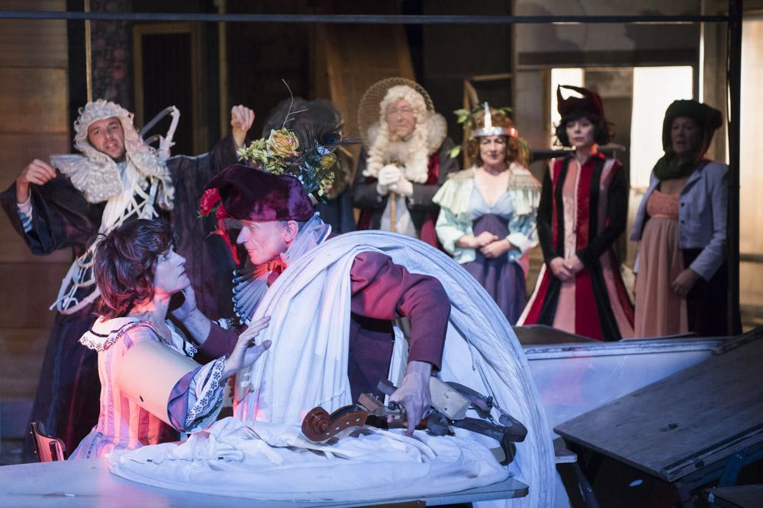
©Karine Pierre

Théâtre du Radeau permanence and movement
Le Théâtre du Radeau has been based in Le Mans since the end of the 1970s. In 1982, François Tanguy joined the company that was founded with Laurence Chable, and became its stage director. In the early 1990s, the company moved into a former garage in the city centre. This space would come to be known as La Fonderie, a workspace open to artists working in the residence and also in militant and associative events. With a new production every two to four years, and with the support of structures such as the Théâtre National de Bretagne in Rennes, the Festival d'Automne in Paris or the Théâtre-Garonne in Toulouse, the Théâtre du Radeau has been performing its works in France and abroad since the late 1980s.
Eric Vautrin in Théâtre Public "Variations Radeau" n°214, octobre 2014

- 2013 Passim, création
Coproducers Théâtre National de Bretagne - Rennes, MC2 Maison de la Culture de Grenoble - Scène Nationale, Le Grand T – Nantes, LU - le lieu unique, Scène Nationale de Nantes, Centre Dramatique National de Besançon - Franche-Comté
- 2011 Onzième, création
Coproducers Théâtre National de Bretagne - Rennes, Association Artemps,-Dijon, Théâtre de Gennevilliers – Centre Dramatique National de Création Contemporaine, Festival d’Automne - Paris, Espace Malraux, scène nationale - Chambéry & Savoie, Théâtre Garonne – Toulouse
- 2007 Ricercar, création
Coproducers TNB - Rennes, Odéon-Théâtre de l’Europe - Paris, Festival d’Automne - Paris, Festival d’Avignon, Centre Chorégraphique National -Rillieux-la-Pape- Cie Maguy Marin, Théâtre Garonne - Toulouse.
- 2004 Coda, création
Coproducers TNB - Rennes, Odéon-Théâtre de l’Europe - Paris, Festival d’Automne – Paris
- 2001 Les Cantates, création
Coproducers TNB - Rennes, Odéon - Théâtre de l’Europe - Paris
- 1998 Orphéon - Bataille - suite lyrique, création
Coproducers TNB - Rennes
- 1996 Bataille du Tagliamento, création
Coproducers TNB - Rennes, Festival d’Automne - Paris, CDN - Gennevilliers, Kunsfest Weimar, Théâtre National - Dijon
- 1994 Choral, création
Coproducers TNB - Rennes, Quartz - Brest,
Théâtre en Mai - Dijon, Théâtre Garonne - Toulouse
- 1991 Chant du Bouc, création
Coproducers Festival d’Automne - Paris, TNB - Rennes, Quartz - Brest, Les Bernardines - Marseille, CDN - Reims. Participation Théâtre Garonne - Toulouse
- 1989 Woyzeck - Büchner - Fragments forains
Coproducers Quartz - Brest, TGP - St Denis, Festival d’Automne - Paris
- 1987 Jeu de Faust, création
Coproducers Atelier Lyrique du Rhin - Colmar , Théâtre des Arts - Cergy Pontoise
- 1986 Mystère Bouffe, création
- 1985 Le songe d’une nuit d’été, de W. Shakespeare
Coproducers Palais des Congrès et de la Culture - Le Mans
- 1984 Le retable de séraphin, création
- 1983 L’Eden et les cendres, création
- 1982 Dom Juan, de Molière

Théâtre du Radeau in France and around the world
Over the last thirty years, the Théâtre du Radeau has performed all over France and been invited to the most prestigious festivals : Festival d'Avignon and Festival d'Automne à Paris.
It has travelled to more than twenty countries, often with the support of the Institut Français.

AUSTRIA Salzburg Festival
BELGIUM De Singel - Antwerpen, Kunstenfestivaldesarts - Brussels, Liege Festival
GERMANY Hebbel Theater - Berlin, Spiel Art - München, Kunstfest, European Capital of culture - Weimar, Kampnagel - Hamburg, Freiburg Festival, Saarbrücken Festival, Hannover Festival , Mannheim Festival , Nürnberg Festival
BOSNIA & HERZEGOVINA Pozoriste Mladih - Sarajevo
BRAZIL Curitiba Theater Festival, SESC Belenzinho - Sao Paulo
CANADA F.T.A – Montreal
CROATIA Eurokaz - Zagreb
CZECH REPUBLIC Quadriennale / Four days - Praha
DENMARK Aarhus Festival
FINLAND Helsinki Festival
GREECE Athens & Epidaurus Festival - Athens
ITALY Teatro Era - Pontedera, Festival - Bergamo, Teatro Valle - Roma, Santarcangelo dei Teatri, Teatri di Vita - Bologna, Biennale di Venezia
SPAIN Madrid Festival, Teatro Romea - Barcelona, Sitgès Festival, Teatro Central - Sevilla, Granada Festival
NORWAY Bit Teatergarasjen - Bergen , Black Box - Oslo
POLAND Center for Contemporary Art - Sala Stodola - Warszawa, Premio Europa per il teatro - Wroclaw
PORTUGAL Teatro Nacional D.Maria II - Lisboa, P.O.N.T.I. – Porto
UTH KOREA Festival Performing Arts (FPA) – Seoul
UNITED KINGDOM Almeida Theatre, Riverside Studios - London, French Theatre Season Riverside Studios, Jersey Festival
RUSSIA NET Festival – Moscow
SWITZERLAND Theaterfestival - Basel, La Bâtie Festival, Comédie et Grand Théâtre – Geneva

Théâtre du Radeau echoes from the press
LE NOUVEL Observateur
"And since Tadeusz Kantor left us, no one has been able to celebrate, as François Tanguy does, such a vivacious and engaging theatre, one of death, of shadow.
Odile Quirot - 12th November 2013

Le Monde
There is, in France, a place where nothing happens like anywhere else: la Fonderie (the Foundry) in Le Mans. It is a large old industrial building in the centre of the city. In 1985, a theatre company settled there, the Théâtre du Radeau. The company founded in 1977, was joined in 1982 by the director François Tanguy. He would blow new life into it and lead it down extraordinary artistic alleyways.
The spirit that presides over the Fonderie evokes a laboratory, a safe haven, a mill: one can take ones time here, research, invent, without being subjected to the laws of artistic productivity. One lives there too, in this beautifully simple place. The company has organised it to host in residence other artists, from various disciplines. There is a kitchen, there are bedrooms, workshops, large halls, all furnished with long wooden tables, with unassorted and found objects, like an attic that is, and the same could be said of François Tanguy, both on the margins and at the very heart of the world.
Brigitte Salino - 14th Dec 2013

Les InRocKuptibles
"Like ghosts crystallized by the words of poets, the actors of Théâtre du Radeau appear in beautiful tableaux vivants (living pictures), only to dissolve into the night the next moment, then to be reborn in other garments."
Patrick Sourd - 18th November 2013

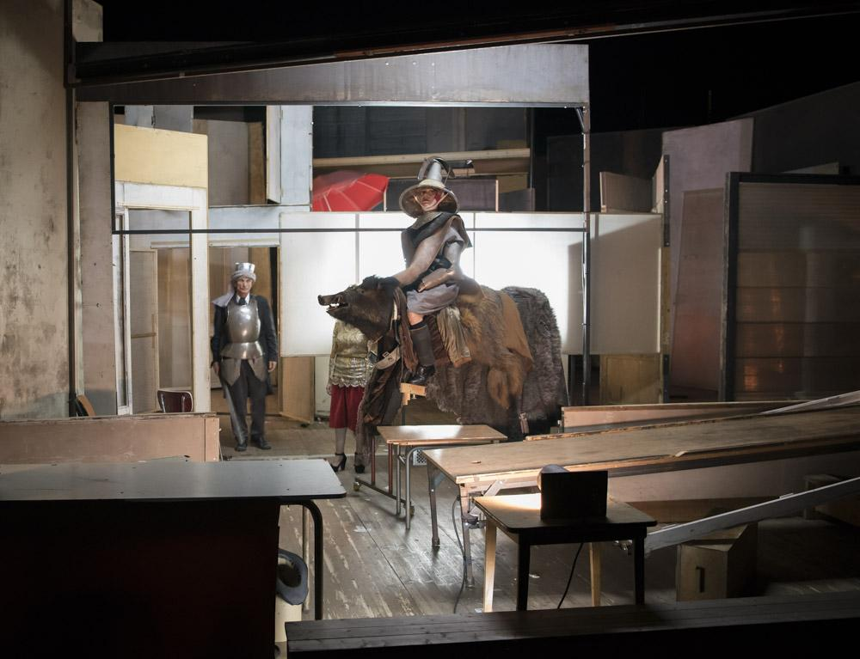
BrigitteEnguerant

Théâtre du Radeau for further reading

LE NOUVEL Observateur
Odile Quirot (Translated by Porter & Cie)

Le Monde « Passim »
Brigitte Salino (Translated by Porter & Cie)

L’Humanité
Jean-Pierre Léonardini (Translated by Porter & Cie)

Insensé-scenes.net Passim : les réderies du Radeau
Yannick Butel (Translated by Porter & Cie)

Le Monde
Fabienne Darge (Translated by Porter & Cie)

Extraits de “ça qui n’est pas là”
Jean-Paul Manganaro (Translated by Porter & Cie)

Soubresaut
François Tanguy (Translated by Porter & Cie)

Article à propos du Théâtre du Radeau
Seuils de pénétration : la traversée du spectateur (à table avec François Tanguy)
Emmanuel Wallon

Écrits sur le Théâtre du Radeau

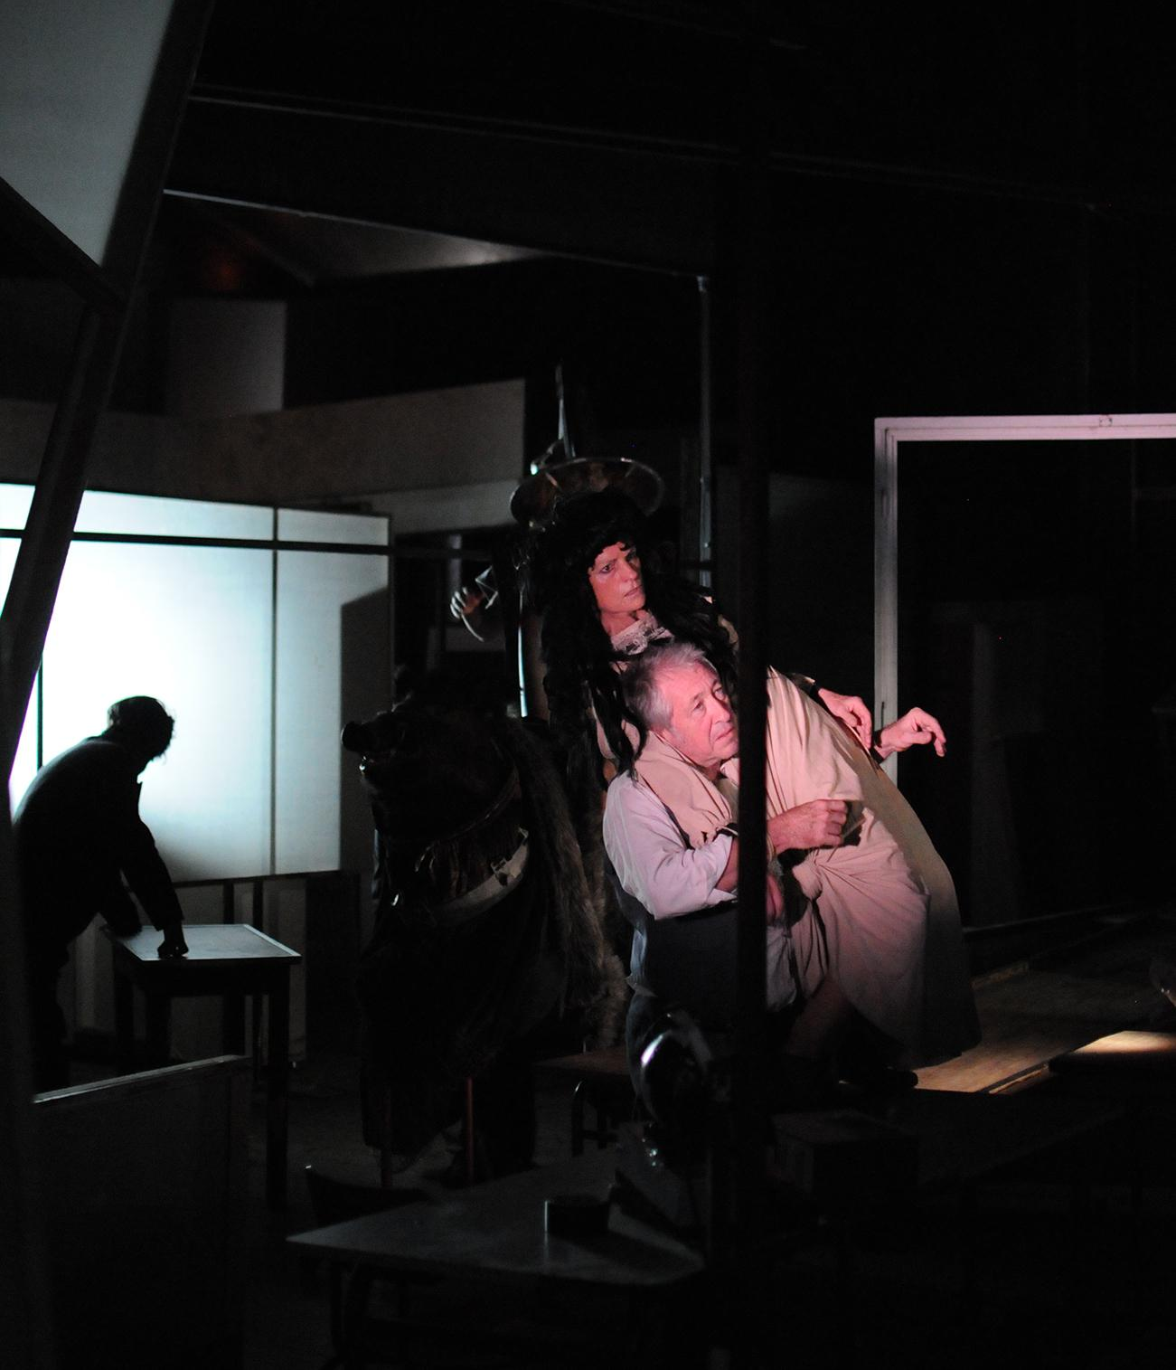
©FrançoisFauvel

Théâtre du Radeau contacts

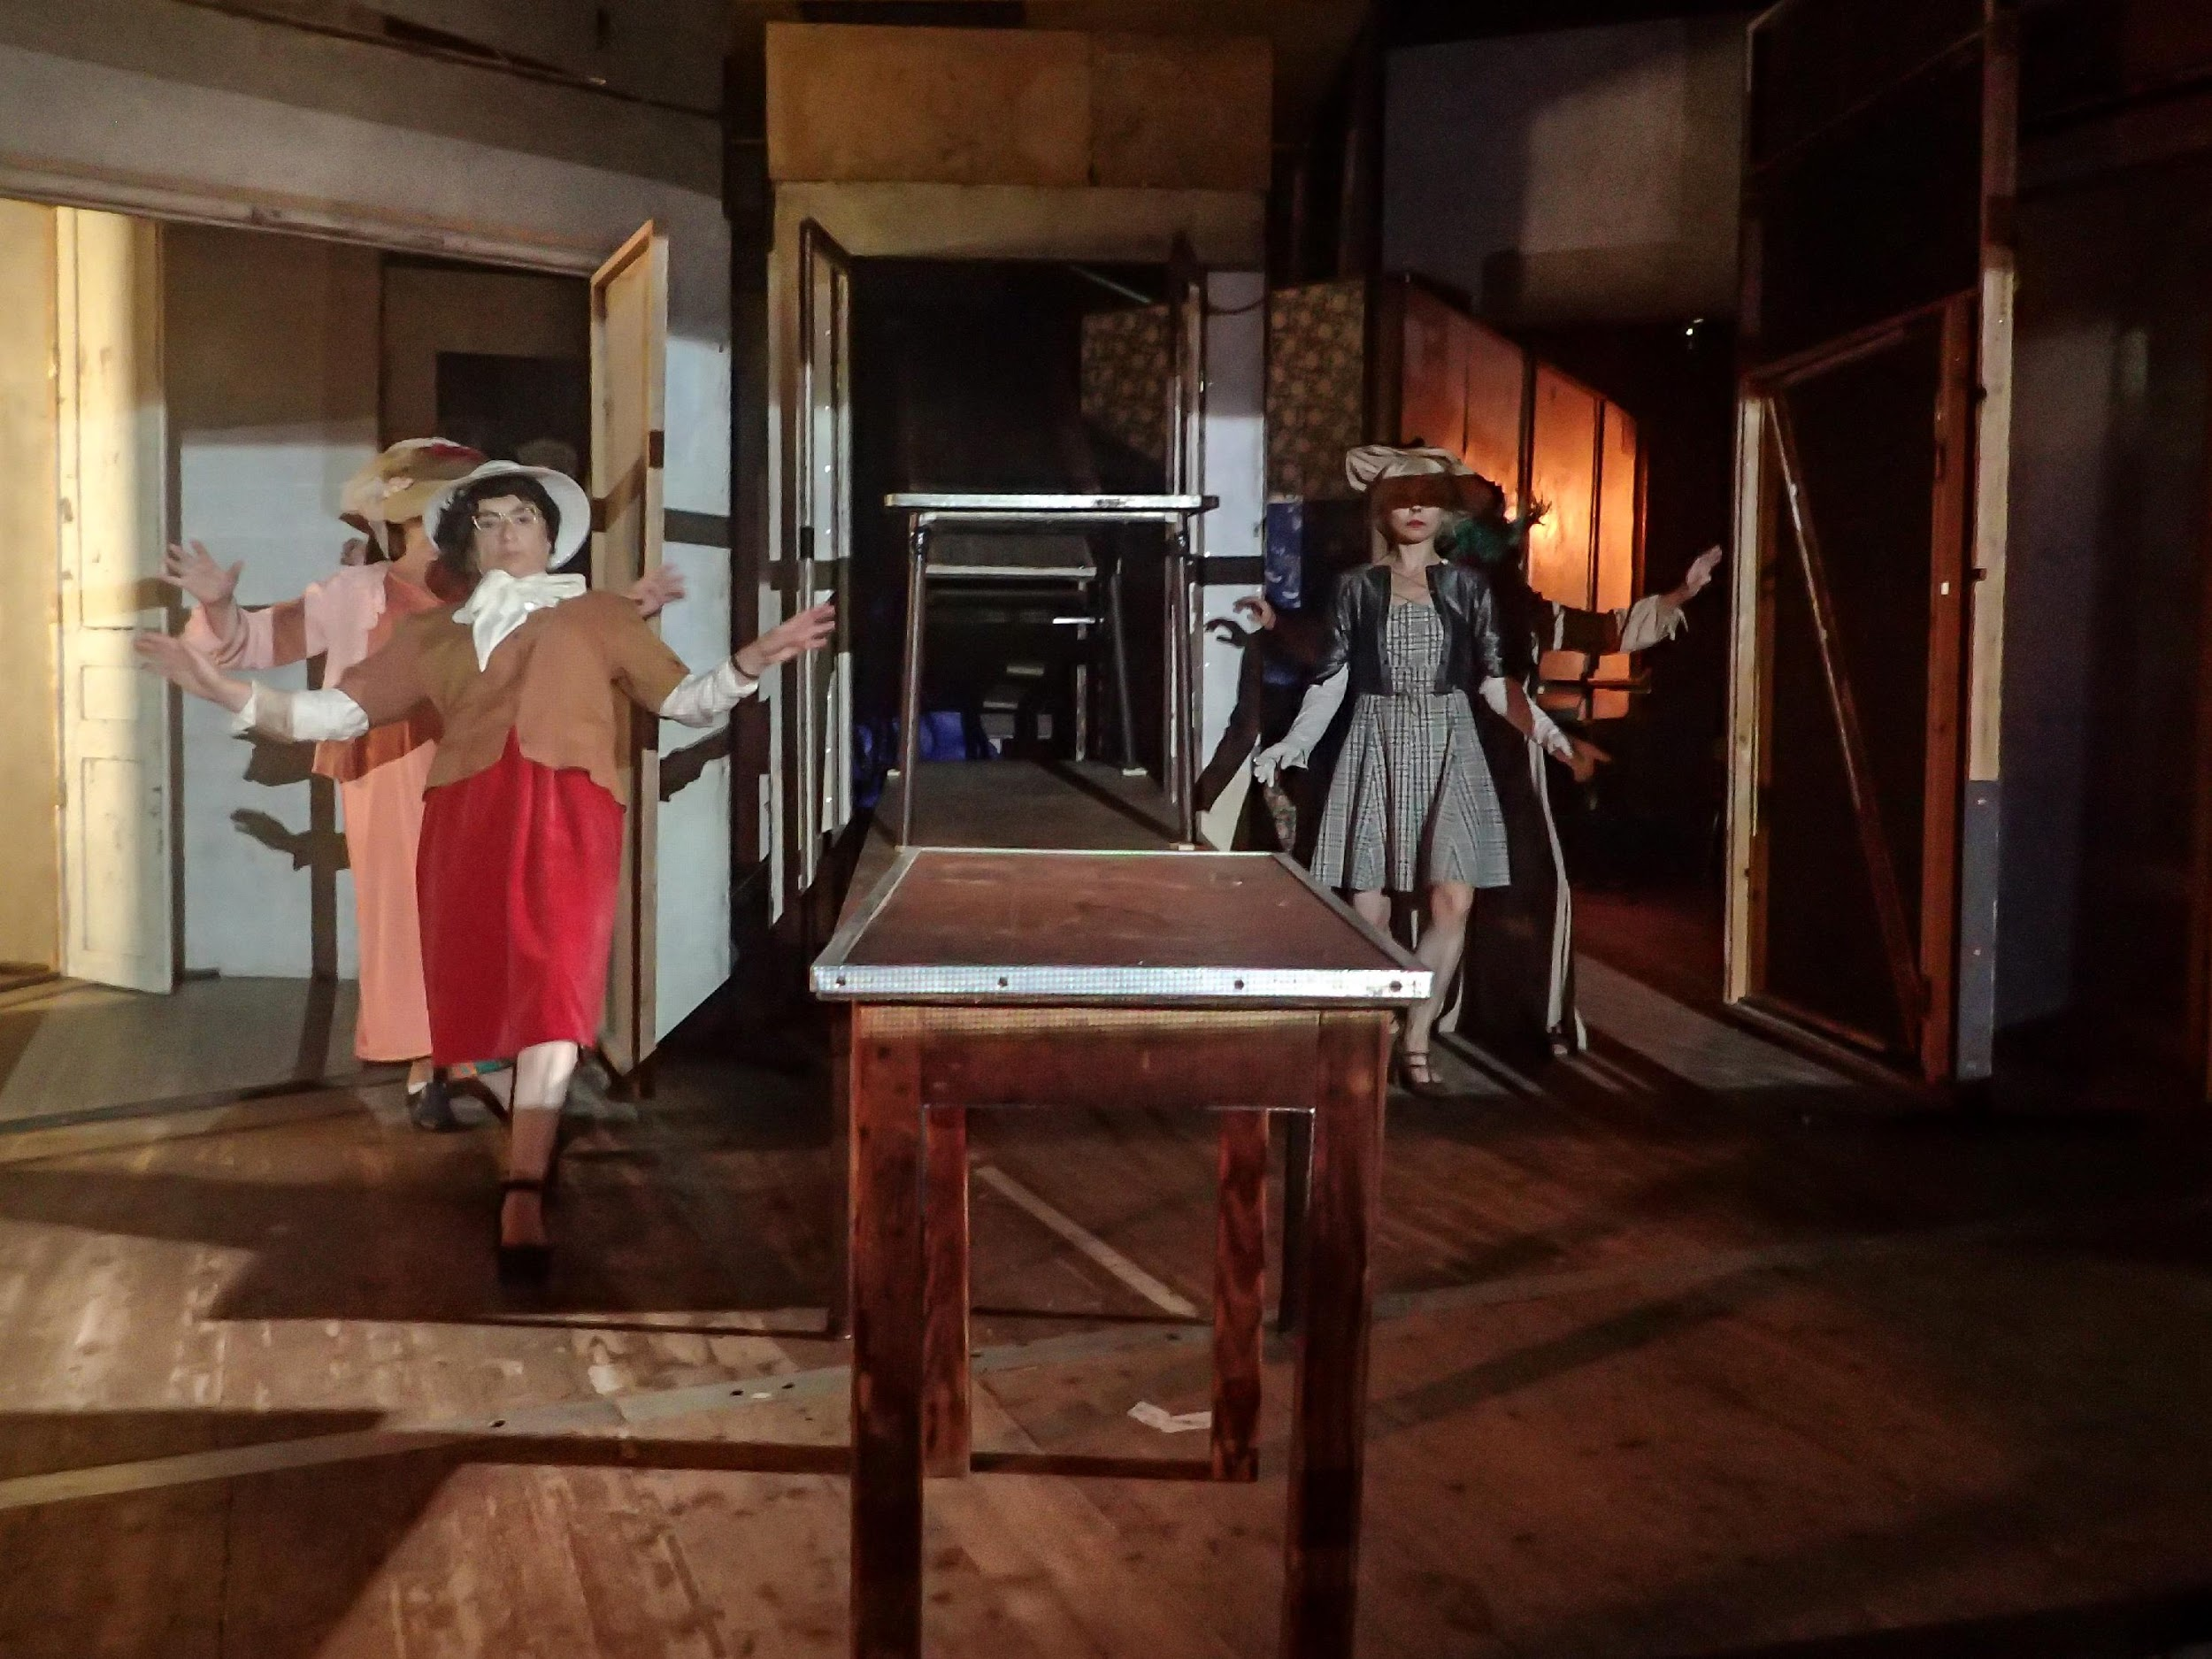©Jean-Pierre Dupuy

BOOKINGS TECHNICAL ENQUIRIES ADMINISTRATION
Geneviève de Vroeg-Bussière François Fauvel Nathalie Quentin
+ 33 6 63 96 24 12 + 33 6 18 93 52 83 + 33 6 08 57 46 37
diffusion@leradeau.fr technique.radeau@gmail.com administrateur@leradeau.fr

Théâtre du Radeau - 2, rue de la Fonderie - 72 000 Le Mans - France

+ 33 02 43 24 93 60
www.leradeau.fr

Le Théâtre du Radeau is supported by
The French Ministry of Culture and Communication, The Pays de la Loire and the Sarthe Regional Councils, the city of Le Mans and Le Mans Métropole

